HW2 Screenshots Submission
(50 points in total; Due 11:59 PM CDT, August 7, 2024)

Requirements: This homework is open book, open slides, and open notes, but you are not allowed to collaborate nor discuss with anyone else before the due time. Any question about the homework should be addressed to the instructor. You are required to follow the instruction to complete all the questions and screenshots. This is an individual homework assignment, so sharing your RM process, screenshots, or answers with other students or parties is considered as cheating, which will be reported to the university authority. In addition, it is your responsibility to make your answers meet the required format; otherwise, you might lose points because of wrong format. Please read, understand, and comply with these requirements in this homework assignment by typing your name as below.

Your Name (First Last): BOLAJI MUYIWA___________

Part 1: A Screenshot of Statement of Accomplishment (20 points).
Your screenshot must meet the three requirements specified in the instruction.

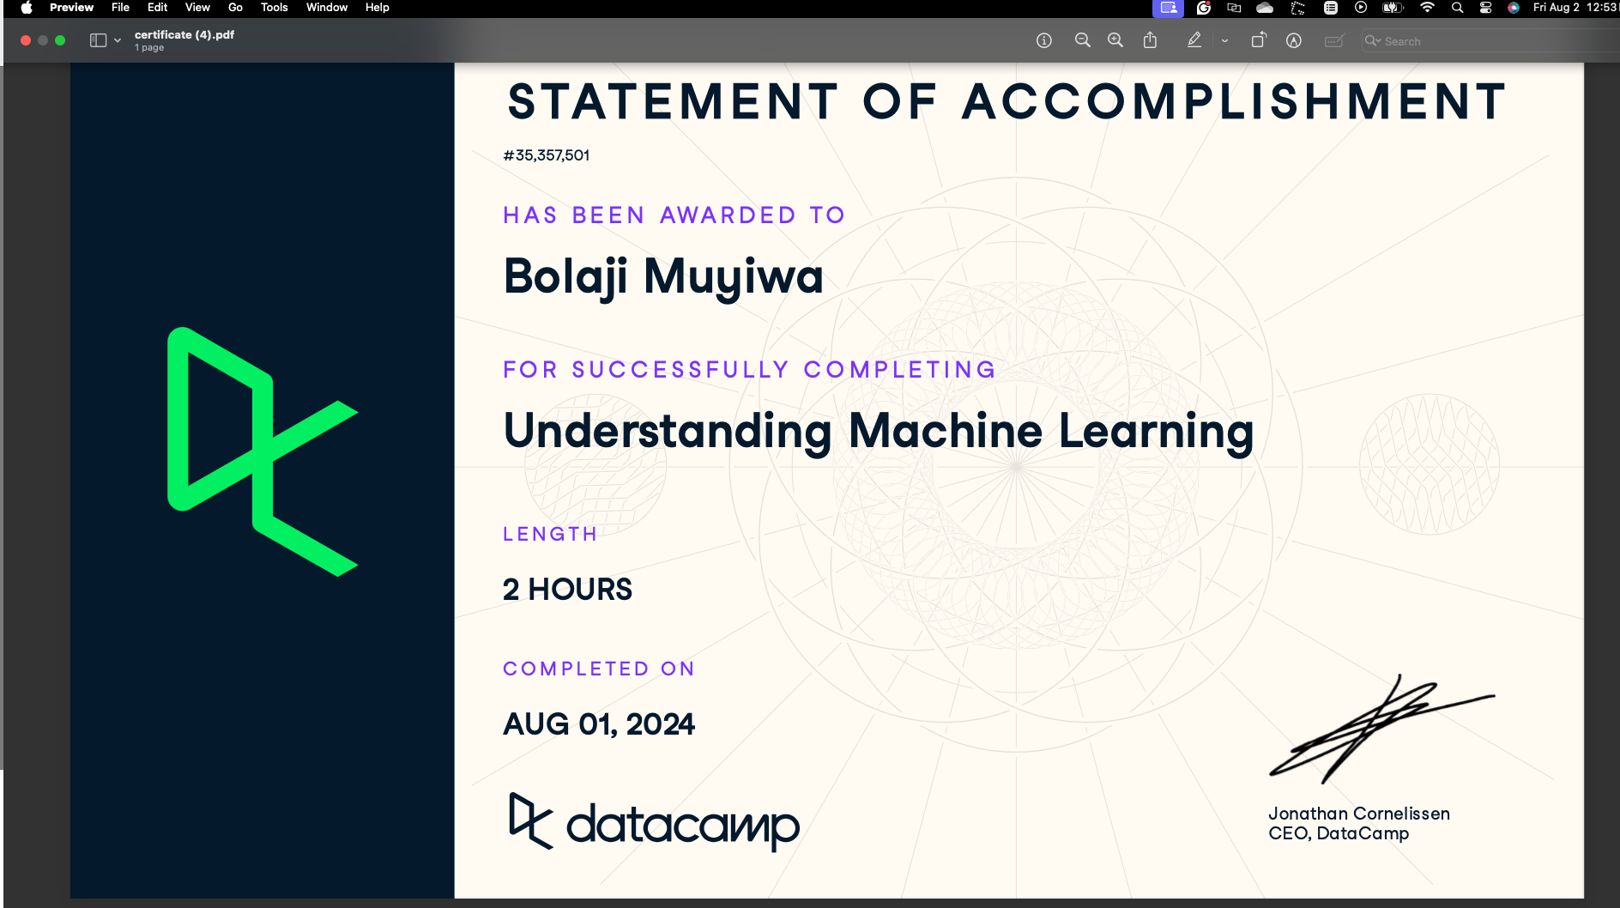

Part 2: Screenshots (30 points)
Each screenshot is worth 6 points, please check if your screenshots meet the requirements.
- Your screenshot must show acceptable date and time (between July 27 and August 8, 2024); otherwise, 6 points will be deducted (i.e., you will get a zero point on this screenshot) with a possible penalty of academic violation depending on further inspection.
- Your screenshot must show what is needed in HW2 Instruction; otherwise, 0 point will be assigned.
- Your screenshot must show all that is needed in HW2 Instruction; otherwise, at least 4 point will be deducted.
- If you miss a screenshot, 0 point will be assigned.
The minimum point on each screenshot is zero. However, if identical screenshots are found from two or more students, a zero point will be assigned to all the involved students and such a case will be reported to the PEV COB Dean’s office.

Screenshot 1: Step 3.5 Take a screenshot of your regression model (the one with regression coefficients and p values) with date and time.

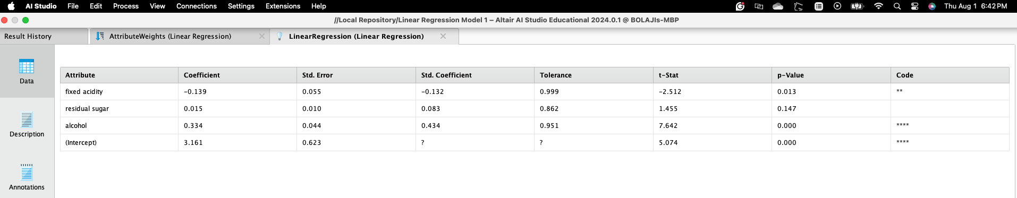

Screenshot 2: Step 4.5 Take a screenshot of your prediction results (the one with predicted quality of the five new wines) with date and time.
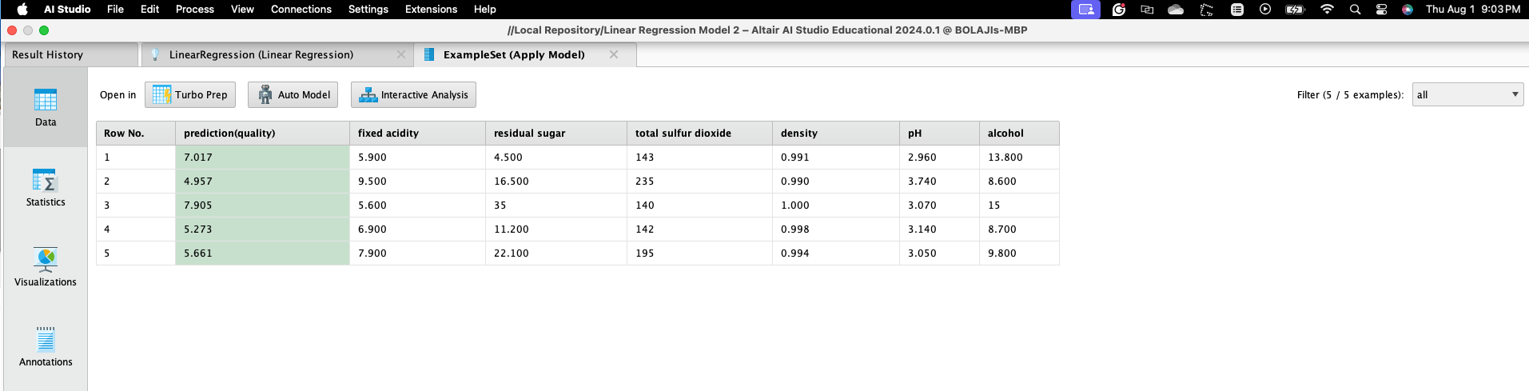

Screenshot 3: Step 6.4 Take a screenshot of your decision tree model (the one with a tree graph) with date and time.
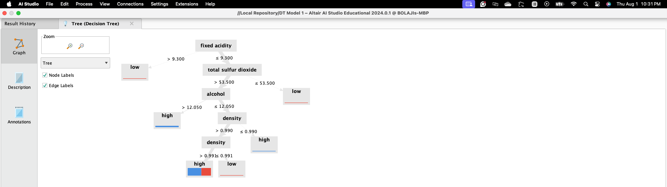

Screenshot 4: Step 7.4 Take a screenshot of your prediction results (the one with predicted quality of the five new wines) with date and time.
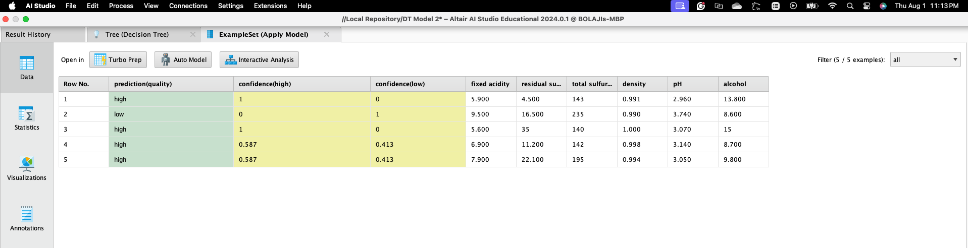

Screenshot 5: Step 9.6 Take a screenshot of your prediction results (the one with predicted quality of the five new wines) with date and time.

